<http://www.programering.com/a/MzMyAzNwATE.html>

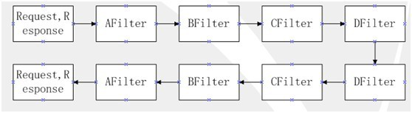

AFilter to DFilter a FilterChain.

　　Now to simulate the Servlet in the FilterChain.

　　First define the interface Filter, because all Filter must comply with the specifications, can be loaded in FilterChain.

1 public interface Filter {
2 void doFilter(Request request,Response response,FilterChain chain);
3 }

　　Next, write FilterChain and Filter.

1 public class FilterChain implements Filter{
2 List<Filter> fs = new ArrayList<Filter>();
3 int index = 0;
4
5
6 public FilterChain addFilter(Filter f) {
7 fs.add(f);
8 return this;
9 }
10
11
12 @Override
13 public void doFilter(Request request, Response response,FilterChain chain) {
14 if(index == fs.size()) return;
15 Filter f = fs.get(index);
16 index ++;
17 f.doFilter(request, response, chain);
18 }
19
20
21 }

1 public class HTMLFilter implements Filter {
2
3
4 @Override
5 public void doFilter(Request request, Response response,FilterChain chain) {
6 request.requestStr = request.requestStr.replace("<", "[").replace(">", "]") + "--HTML--";
7 chain.doFilter(request, response, chain);
8 response.responseStr += "--HTML--";
9 }
10 }

1 public class SensitiveFilter implements Filter {
2
3
4 @Override
5 public void doFilter(Request request, Response response,FilterChain chain) {
6 request.requestStr = request.requestStr.replace("The employment "," employment ").Replace (" sensitive", "\*\*") + "--Sensitive--";
7 chain.doFilter(request, response, chain);
8 response.responseStr += "--Sensitive--";
9 }
10
11
12 }

　　Finally, the test class.

1 public class Test {
2
3 /\*\*
4 \* @param args
5 \*/
6 public static void main(String[] args) {
7 String msg = "Test, <script>, the employment, the sensitive information";
8 FilterChain fc = new FilterChain();
9 fc.addFilter(new HTMLFilter()).addFilter(new SensitiveFilter());
10 Request request = new Request();
11 request.setRequestStr(msg);
12 Response response = new Response();
13 response.setResponseStr("response");
14 fc.doFilter(request, response,fc);
15 System.out.println(request.getRequestStr());
16 System.out.println(response.getResponseStr());
17 }
18
19 }